Morphing Hydrofoil

Fall 2025 ME Executive Summary

Design Team
Vanessa Khangi, Lily Knott, Oscar Wilmerding, Adrian Winkelman, Jack Wortman

Design Advisor
Prof. Safa Jamali

Abstract
Fixed-wing hydrofoils are widely used today in racing; however, these foils force a trade‑off: high lift at low speeds or low drag at high speeds. While current racing boats implement trailing-edge flaps on the foils to address this, they still fall short of their optimal performance. As a solution, a morphing hydrofoil would be capable of switching profiles mid-race to optimize lift and drag coefficients. Through extensive background research, it was decided that a cam-driven mechanism to control thickness and a linkage-driven mechanism to control camber would be best suited to achieve this goal. Using an optimized AC75 profile from the University of Michigan as a baseline, a series of simulations under different fluid conditions were conducted in XFoil to develop a set of idealized profiles. These morphing mechanisms are encased in a compliant outer skin to keep a continuous profile. This work can be further developed with a Phase II project that aims to create a full wing suitable for testing in the water. A deeper focus could be put into areas such as skin material, electronic feedback systems, internal structures, and further optimization of the full wing profile.

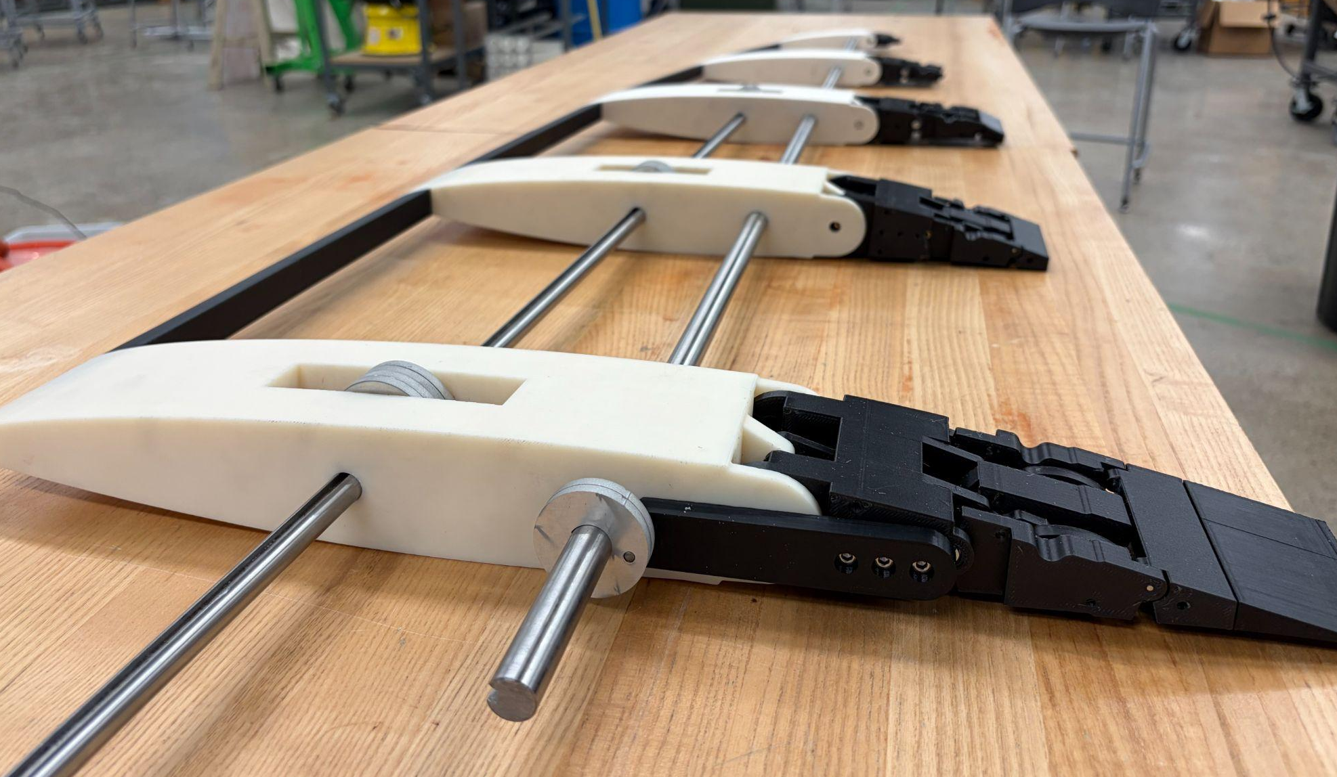

For more information, please contact s.jamali@northeastern.edu.

Need
Modern racing sailboats rely on fixed hydrofoils that are forced to balance high lift at low speeds and low drag at high speeds. These limitations prevent optimal performance across the full range of racing conditions, especially as the boats approach cavitation speeds. To mitigate these effects, static foils often use flaps. The sharp profile changes caused by these flaps, however, result in high pressure drops across the foil which lead to performance losses from cavitation, flow separation, and turbulence. Our solution addresses this by developing a morphing hydrofoil that can continuously adjust its thickness and camber mid-race to maintain ideal lift and drag characteristics. This technology can provide different watercrafts, ranging from passenger ferries to racing boats, with a new tool to achieve higher efficiency across all conditions.

Background and Significant Prior Work
Hydrofoils operate on the same fluid dynamic principles as the wings on an aircraft, generating lift as water flows around the surface. As the foil moves through a fluid, its curved shape generates lift and drag. Lift, which is always perpendicular to the direction of the incoming flow, is the net upward force on the foil. Drag is the resistance force the foil experiences as it moves through the fluid, acting opposite to the flow direction. Cavitation is a phenomenon that occurs when the local pressure on the suction side of a hydrofoil drops below the vapor pressure, causing a phase change from liquid to vapor at that localized point. As a result, the foil drastically loses lift, suffering a large decrease in performance. Cavitation plays a crucial role in high-performance sailing, as foiling boats begin to reach maximum cavitation speeds while still maintaining low-speed performance.
Thick foils with a high curvature parameter, or camber, generate strong lift for low speeds, while thinner, straighter foils minimize drag at high speeds. This means a single fixed hydrofoil is not able to perform optimally across different flow conditions. Current racing series, such as the America’s Cup (AC75) and SailGP F50, use fixed foils with flaps to balance these trade-offs. The downside is that these solutions create hinge gaps that cause flow separation, turbulence, and early cavitation. As a result, race boats must swap entire foil assemblies between races to match conditions, limiting versatility and efficiency. A morphing hydrofoil offers a way to dynamically adapt and optimize geometry mid-race for both low-speed lift and high-speed drag reduction, a capability not yet available in competitive sailing.
Prior research in this field has been led mostly by the aerospace community. During research, a few main internal mechanisms appeared as common solutions: servo-driven systems, internal pressure-driven systems, shape memory alloy (SMA) actuation, and linkages. Servo-driven systems typically rely on compliant ribs or linkages to create morphing. Morphing airfoils that have utilized this mechanism have demonstrated smooth camber transitions that reduce drag and delay stall [1] [2]. While servos typically lead to accurate results, they introduce mechanical complexity and are unable to perform well under heavy loads. Pressure-based systems, such as internal honeycomb structures that expand and contract via pneumatic actuation, were also shown in existing research to achieve measurable shape change and reduce cavitation [3] [4]. The major downsides to these systems are the complex packaging and manufacturing. SMA actuation was an approach that used thermally induced strain to create a morphing profile. While this could be easily packaged, the thermal response time severely limits quick morphing, which is critical for racing. In addition, the foil is constantly undergoing convective heat transfer from the surrounding water, making it difficult to reach the temperatures required for deformation. Despite these advances, few existing designs account for underwater applications. Existing research largely does not explore the hydrodynamic and structural demands of racing hydrofoils, where waterproofing, corrosion resistance, and high-pressure loading are the main challenges.
To maintain a smooth and continuous shape during morphing, the outer surfaces of the hydrofoil require materials that are flexible enough to deform, yet rigid enough to withstand hydrodynamic loading [5]. To inform material selection, existing aerospace and marine applications were reviewed. Carbon fiber is widely used in high-performance hydrofoils for its desirable strength and stiffness-to-weight ratios and corrosion resistance [6] [7]. Additionally, the layup process can be adapted to create compliant regions, as demonstrated by Arab et al., who achieved measurable deflection by varying ply count and fiber type within the laminate [8]. Another strategy uses segmented skins composed of alternating stiff aluminum components and highly compliant elastomeric foam covered by a silicone layer, which localizes soft regions to reduce unwanted deformation under load [4]. Reinforced elastomers offer high compliance due to their low elastic modulus [9] [10]. Studies such as Bubert et al. show that embedding unidirectional carbon fibers within a silicone elastomer and pairing it with a honeycomb substructure can achieve large in-plane strain capacity and controlled out-of-plane stiffness [11]. Our project builds directly on these studies by integrating a linkage-based internal mechanism with an experimental silicone-based compliant skin, paired with carbon fiber molding. Together, these developments aim to produce a functional proof of concept that demonstrates continuous morphing of both camber and thickness, leading to advancements in marine engineering.

Design Solution

Overview
The design of our hydrofoil focuses on two main morphing mechanisms: cam-driven thickness control and linkage-driven camber control. A series of ribs integrates the two driving mechanisms that make up the internal skeletal structure. Two axles, one for each mechanism, connected the ribs spanwise and are actuated via stepper motors. The two stepper motors, one for each mechanism, sit outside the foil. The entire internal mechanism is enclosed in an outer shell. This system allows for quick and accurate morphing while maintaining a continuous profile and avoiding any sharp angles.

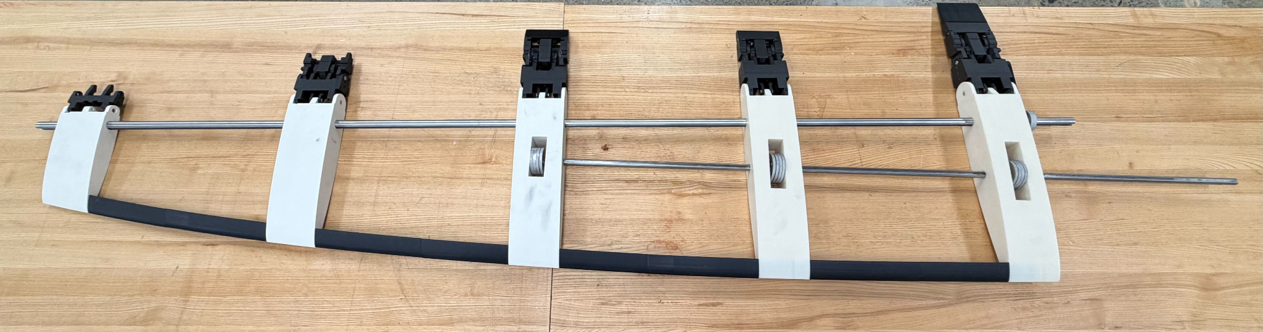
Figure 1: Morphing Wing Internal Structure and Mechanisms

Thickness Control
The thickness of the profile is controlled using a series of cams on a common driving axle. As the axle is rotated by its respective stepper motor, the cam will also rotate and force the outer shell to deflect upward or downward.

Camber Control
The camber adjustment of the wing profile is controlled by a linkage system, driven by one shared axle. The purpose of this mechanism is to adjust the curvature of the trailing edge in a more continuous manner as opposed to the hinged wing flaps that are commonly used. A series of linkages is connected to multiple hinged sections in such a way that constrains the movement to a single axis of rotation.

Outer Skin
The outer surface of the hydrofoil is composed of two materials: a carbon fiber shell covering the leading edge and a reinforced elastomer skin covering the trailing edge. The carbon fiber on the leading edge is only semi-flexible, which enables a gradual deflection without causing a lump at the point load induced by the cam mechanism. The trailing edge skin is an elastomer reinforced with uniaxial carbon so that it is flexible in-plane for camber adjustment but rigid out-of-plane, enabling it to withstand external loading. The two materials are connected via a cleat system, as seen in Figure 2 below. Thin sheet metal brackets are embedded into the silicone and bent at a sharp angle to form ‘B’ cleats, and mating ‘A’ cleats are formed from the same sheet metal and epoxied along the inner lip of the stiff carbon fiber shell.

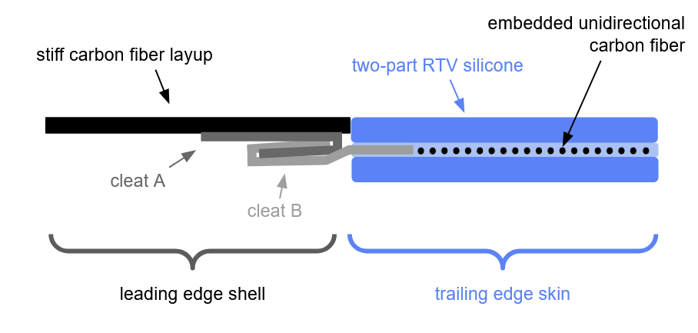

Figure 2: Cross-section of Outer Skin Material Stackup

Summary
The morphing capabilities of our hydrofoil are driven by two mechanisms: cam-driven thickness control and linkage-driven camber control. Each mechanism is driven by an axle that extends down the span of the foil, resulting in two total axles. The cams are constrained within support ‘ribs’, which simultaneously act as the internal structure of the foil. The linkage mechanism is designed such that the trailing edge keeps a gradual curvature as opposed to the traditional hinged flaps commonly seen on foils. The internal structure and mechanisms are encased in an outer skin that is carbon fiber on the leading portion and a reinforced elastomer on the trailing portion. The semi-flexible carbon fiber over the cam mechanism has a gradual deflection when subjected to the point load caused by the cam. The reinforced elastomer was made using RTV silicone with unidirectional carbon fiber embedded so that the skin is elastic in one direction but stiff in the other.

Design Process

Overview
The design process for the morphing hydrofoil includes the simultaneous development of three main components: the internal structure and mechanism, cross-sectional profile, and outer shell material.

Internal Mechanism
The initial stage of the design process focused on selecting the best-suited morphing mechanisms for thickness and camber control. Several methods, including airbags and hydraulic linkage systems, were considered before landing on the final solution [4]. By determining that the three primary goals were simplicity, packaging, and ease of morphability, a cam-driven thickness control and linkage-based camber control were opted for as the most viable solutions. This was done using a simple decision matrix that weighed the set design priorities and selected the choice best satisfying the three primary goals. The primary tradeoffs of a hydraulic linkage system provided increased complexity and high costs, while the airbag system involved complex packaging and manufacturing with a large emphasis on research and testing. As a result, the cam system provides a relatively simple mechanical solution that can be easily machined and customized to any size. The linkage mechanism, while more complex, provides high fidelity and accurate camber adjustment that can also be scaled to fit within the geometric taper of the physical system.
The design of the linkage system began in SolidWorks with a series of sketches used to visualize and constrain the linkage geometry. The objective was to produce a compact morphing mechanism that could fit within the foil’s structure while achieving smooth curvature change rather than a discrete hinge motion. Initial prototypes were 3D printed to confirm mechanical feasibility and ensure the linkage operated without interference. The Watt-1 configuration was chosen to meet the single degree of freedom requirement verified through Gruebler’s equation.
Degrees of Freedom = 3(N - 1) - 2L + H (1)
where N is the total number of links, L is the total number of joints with one degree of freedom, and H is the total number of joints with 2 degrees of freedom. Designing around this equation means that the whole system can be actuated with a single motor. The mapping of the motion was done by measuring ten discrete input angles to characterize the nonlinear relationship between the input motion and the two output links that define the trailing-edge curvature. The data were fitted to trendline equations that characterized the kinematic response. Physical testing revealed challenges such as backlash, tolerance stacking, and jamming at singularities.
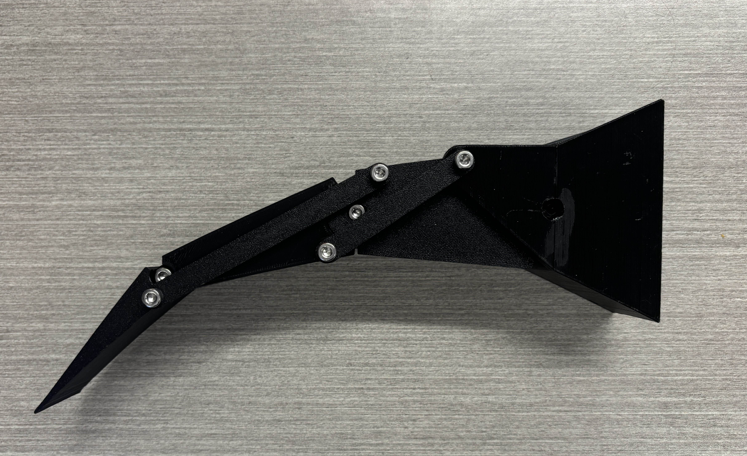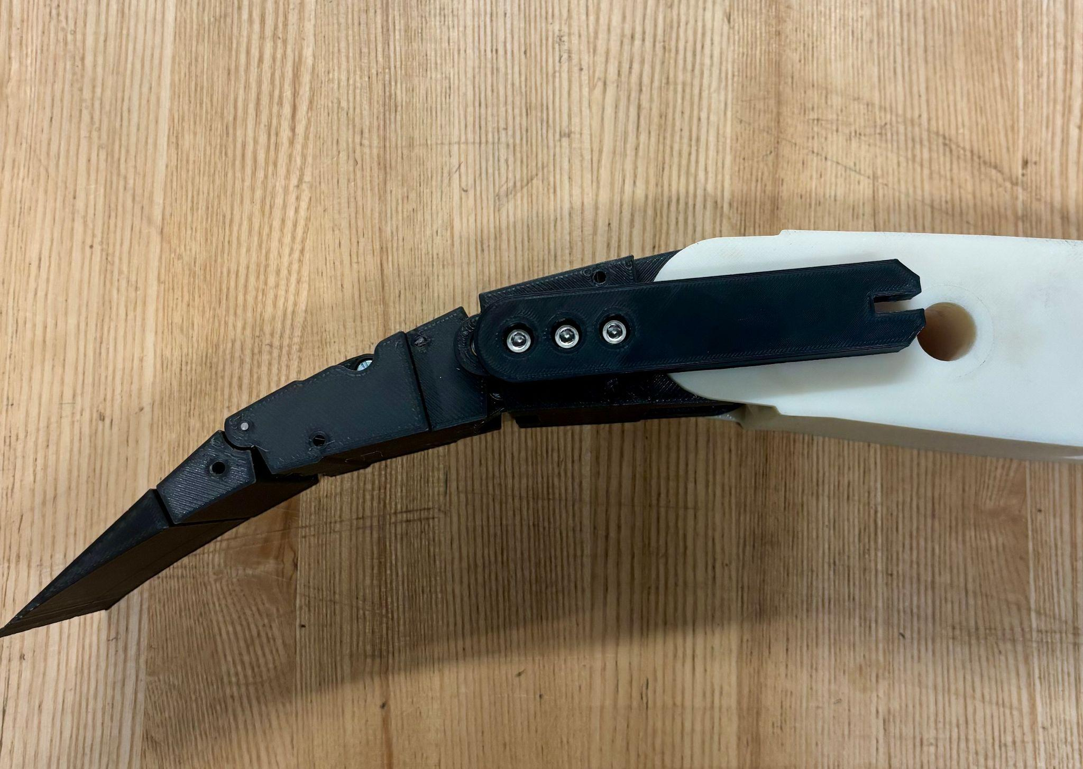
Figure 3: First (Left) vs. Final (Right) Trailing Edge Design
Subsequent iterations resolved these issues through redesigned hinge geometry, bushing implementation, and slight relocation of pivots to keep the linkage motion away from singular configurations. The second iteration introduced symmetric reinforcement for higher load capacity and improved motion smoothness.
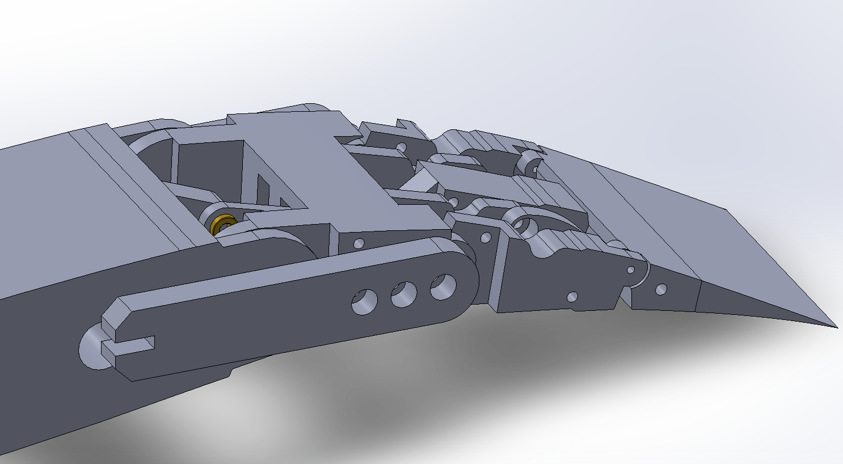
Figure 4: CAD for the Trailing Edge Linkage Mechanism
Throughout the design process, multiple full rib prototypes were created to test the functionality of our different subsystems. The prototype took an 80mm section of the full-scale hydrofoil a`nd included both the cam and linkage mechanisms. For the second full rib prototype, a bigger emphasis was placed on the material for the shell. The purpose of this prototype was to test out the composite layup process of the carbon fiber, as well as test the flexibility of the reinforced silicone skin over the trailing edge. For this prototype, a 50% scale model with a simplified version of the trailing edge was created.

Profile Selection
In parallel, a computational fluid dynamics (CFD) study was conducted in XFoil, a high-speed 2D CFD solver, to determine the optimal profiles to morph between. The baseline profile was an optimized version of the AC75 hydrofoil profile obtained from a CFD optimization study performed by Professor Joaquim Martins and his team at the University of Michigan [10]. A parameterized CAD model was then developed to represent the behavior of the morphing system, mimicking thickness adjustment in the leading edge and camber adjustment in the trailing edge, defined by our specific cam and linkage systems. The profiles were analyzed in XFoil under the same operating conditions and design points set aside in Professor Martin's study. These design points, stated in Table 1 below, are defined by the Reynolds number (Re), lift coefficient (C_{L}), and cavitation coefficient (σ).
Table 1: Hydrodynamic Foil Design Points
Design Point ID | Re | C_{L} | 𝜎
P1 | 3.5 x 10⁶ | 0.5 | 0.52
P2 | 5.0 x 10⁶ | 0.26 | 0.38
P3 | 6.0 x 10⁶ | 0.19 | 0.33
P4 | 4.0 x 10⁶ | 0.37 | 0.44
P5 | 6.0 x 10⁶ | 0.18 | 0.33
P6 | 8.0 x 10⁶ | 0.13 | 0.32
M1 | 1.0 x 10⁶ | 1.3 | -

In this table, design points 1 through 3 represent upwind sailing conditions, points 4 through 6 represent downwind sailing conditions, and point M1 represents the takeoff condition. The goal of this study was to reduce drag, decrease flow separation, and minimize pressure spikes in flap-driven designs. This resulted in the identification of target profiles that the foil control mechanisms can shift between.
The packaging of the internal mechanisms dictated the 3D profile and taper of the wing to allow for realistic shaft alignments with respect to target wing span and chord taper. After evaluating how different tapering options affected the internal mechanisms, the final shape was centered around the driving axis of the linkage system. This 3D geometry allowed us to fit both mechanisms up to where the profile tapers to 50% the original size, which is 72 inches in total length. This resulted in a slightly shorter active wingspan, where a traditional flap or fixed wing is placed on the remainder of the wing.

Outer Skin Material
Several experiments and research into similar applications [7] [11] were conducted to determine the outer shell of the hydrofoil. It was determined that the skin for the leading edge and the trailing edge would be made of two different materials. The leading edge requires a stiffer material to ensure the cam creates a smooth and continuous thickness adjustment, rather than an abrupt change. Camber adjustment, on the other hand, requires a material that can flex significantly in plane while maintaining rigidity along the span. The entirety of the shell also needs to be able to withstand the hydrodynamic pressure it will experience during use. After evaluating which materials were readily accessible and cost-effective, and experimenting with them to understand their behavior, we determined that the leading edge should be made from a thin carbon-fiber layup, while the trailing edge should be constructed from silicone reinforced with uniaxial carbon fiber. These materials were selected for their suitability for rapid prototyping; however, additional research, testing, and validation would be required before transitioning to full-scale, real-world use.
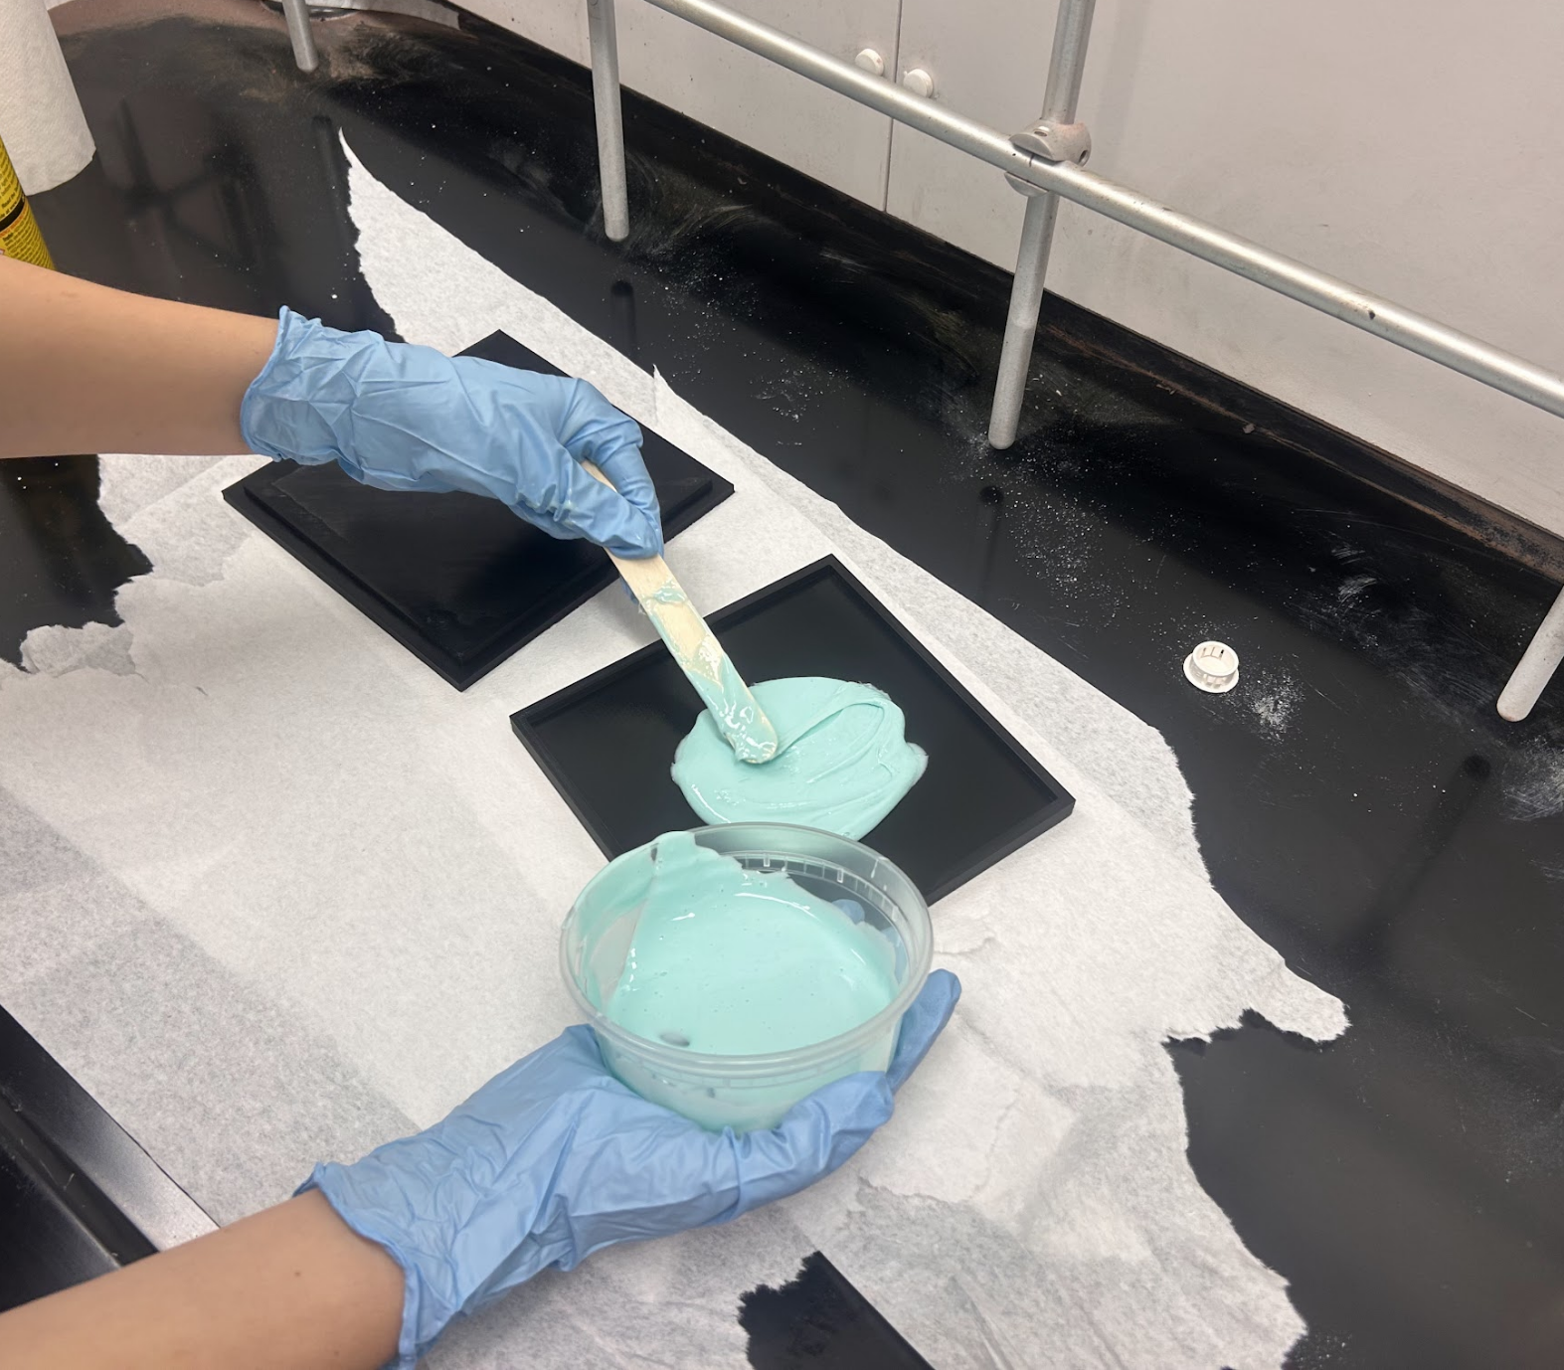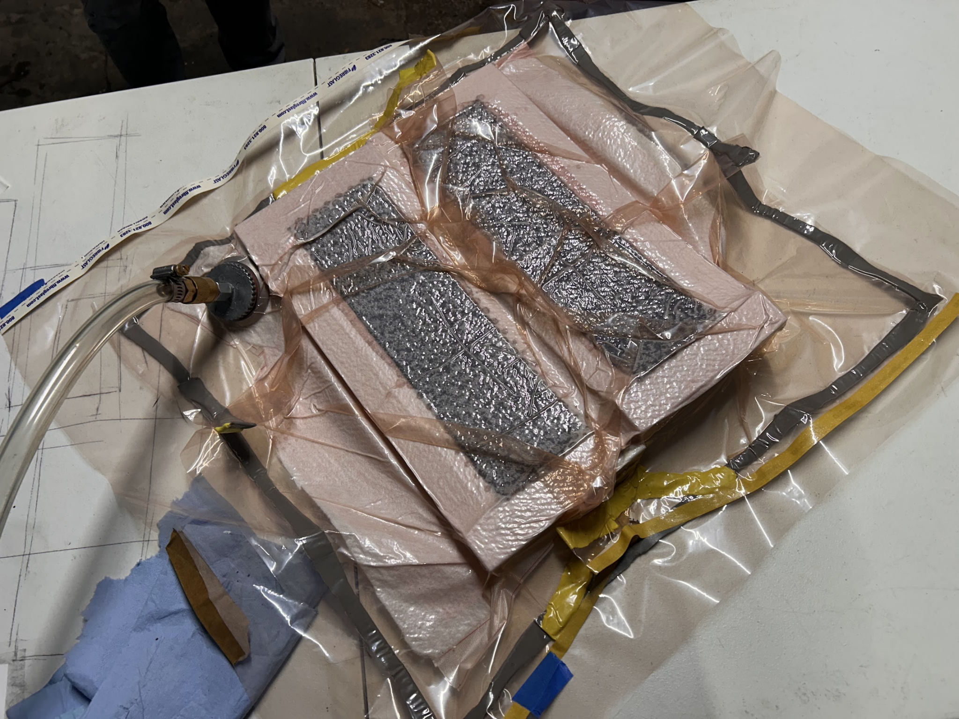
Figure 5: Silicone Test Swatch (Left) and Carbon Fiber Layup Test (Right)

Summary
The development of the hydrofoil was divided into three main components carried out in parallel: the internal mechanisms, the foil profile, and the outer skin. Work on the internal mechanism focused primarily on the trailing-edge linkage system, refined through multiple iterations and prototypes to achieve smooth, predictable motion. The base 2D foil profile was taken from an optimization study by Professor Martins at the University of Michigan [7], then evaluated in XFoil with various modifications in thickness and camber across the fluid conditions listed in Table 1. Using the base profile, the wing was extruded so that the 3D geometry centered around the linkage axle. With this geometry, both mechanisms are able to fit up to the point where the profile tapers to 50 percent, resulting in a functional 6-foot active span.
The outer skin utilizes two materials selected to strike a balance between flexibility and structural stiffness. A rigid carbon-fiber layup forms the leading edge, providing sufficient stiffness to smooth the point loads from the cam mechanism while still allowing for small deflections. The trailing edge is made from silicone reinforced with unidirectional carbon fiber, which allows easy in-plane bending for camber changes while remaining stiff out-of-plane under hydrodynamic loading. Tensile and deflection tests showed that the reinforcement maintains the silicone’s stretch while significantly increasing stiffness where needed.

Results
One of the first steps in developing the morphing hydrofoil was determining the cross-sectional profile to morph between to improve hydrodynamic performance. By replacing the sharp angles in the original profiles with a continuous profile, drag was greatly reduced and pressure spikes, which can lead to stall and cavitation, were essentially eradicated. In the most extreme case, takeoff where lift needs to be at its highest, there was a 23.87% reduction in the drag coefficient and a 34.83% reduction in the pressure coefficient. These results are shown in Figure 6 below.
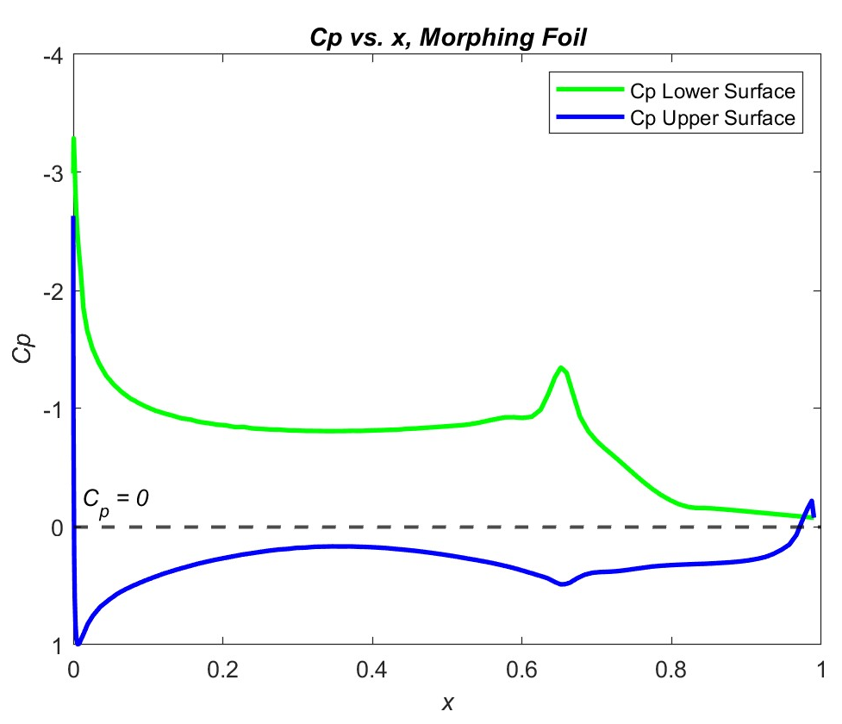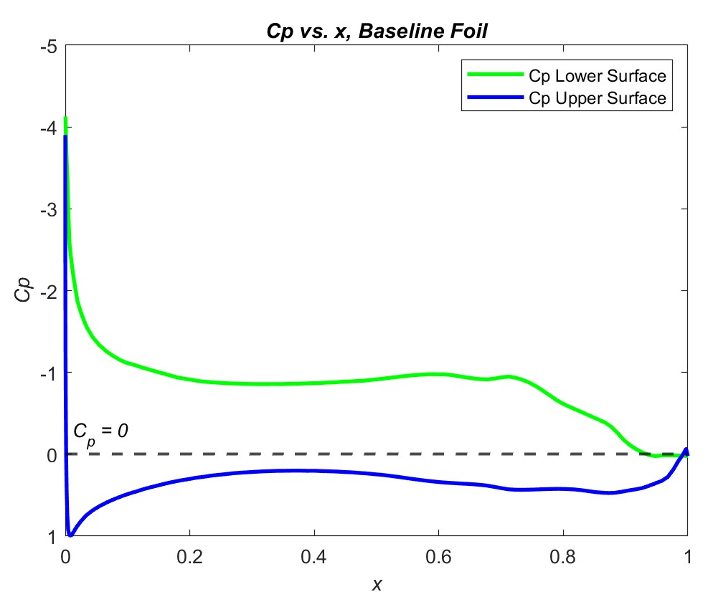
(a) (b)
Figure 6: Pressure Coefficient vs x for the Baseline Profile (a) & Optimized Profile (b) at M1 Condition
Table 2: Performance Comparison for the M1 Condition
 | Alpha (⍺) | C_{L} | C_{D} | C_{M} | C_{p, Min}
Baseline | 2.00 | 1.0438 | 0.02111 | -0.1519 | -1.3450
Optimized | 1.81 | 1.0438 | 0.01607 | -0.1757 | -0.8765
% Change | -9.69 | 0 | -23.87 | 15.67 | -34.83

While the cam mechanism was able to control the thickness of the foil successfully, its precision along the span is limited due to its simplicity. With only a single axis along the entire span for the cams to rotate about, the cross-sectional thickness can only be directly controlled at a single point.

Compared to traditional hinged wing flaps, our trailing edge was able to achieve a smoother camber change while still being driven by a single axis. The linkage mechanism generated a curved deflection along the trailing edge rather than a sharp hinge rotation, enabling smoother hydrodynamic transitions and improved flow attachment across the range of motion.
Our final design incorporates improved geometry, bushings to minimize friction, and a fully symmetric structure that distributes load evenly. These design refinements eliminated binding at singularities and reduced backlash, resulting in inconsistent motion through the full range of deflection. The trailing edge is capable of flexing between its designed range of –15° to +5° and successfully transitions between the upward, neutral, and downward camber states.
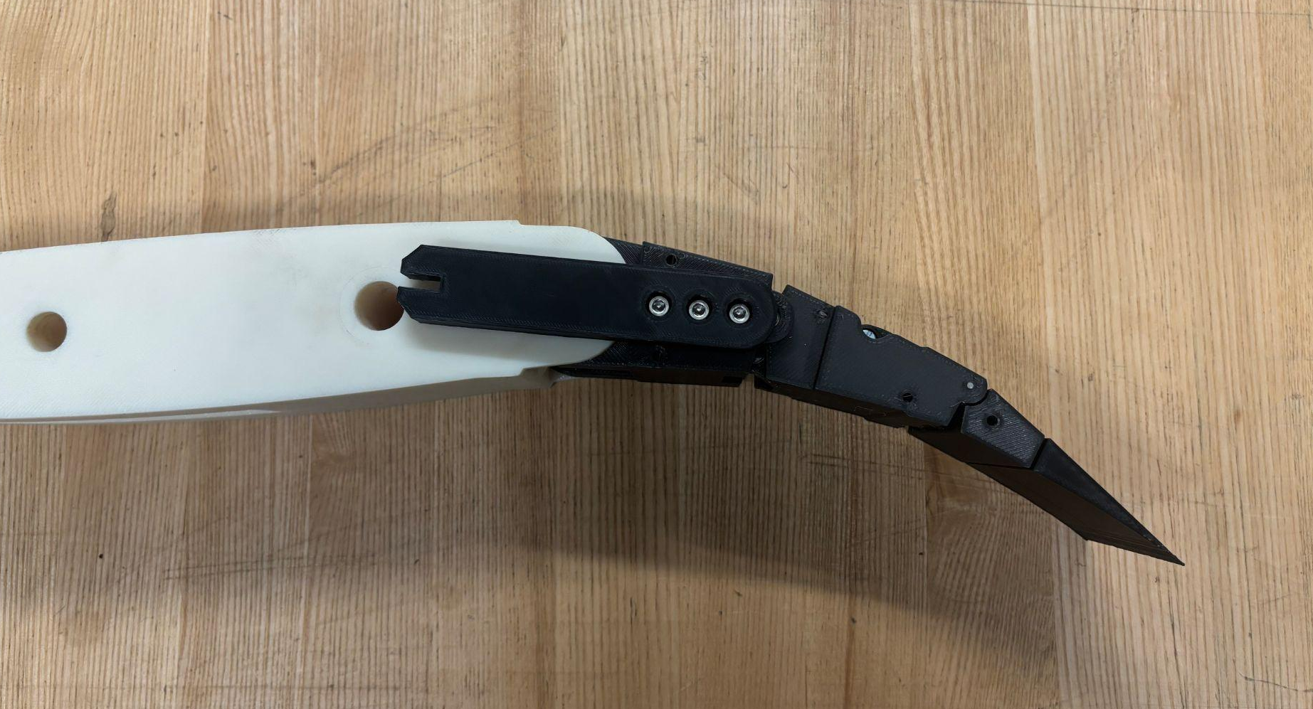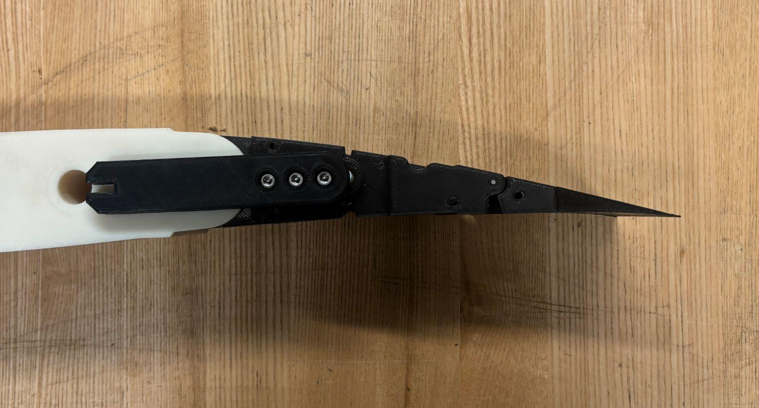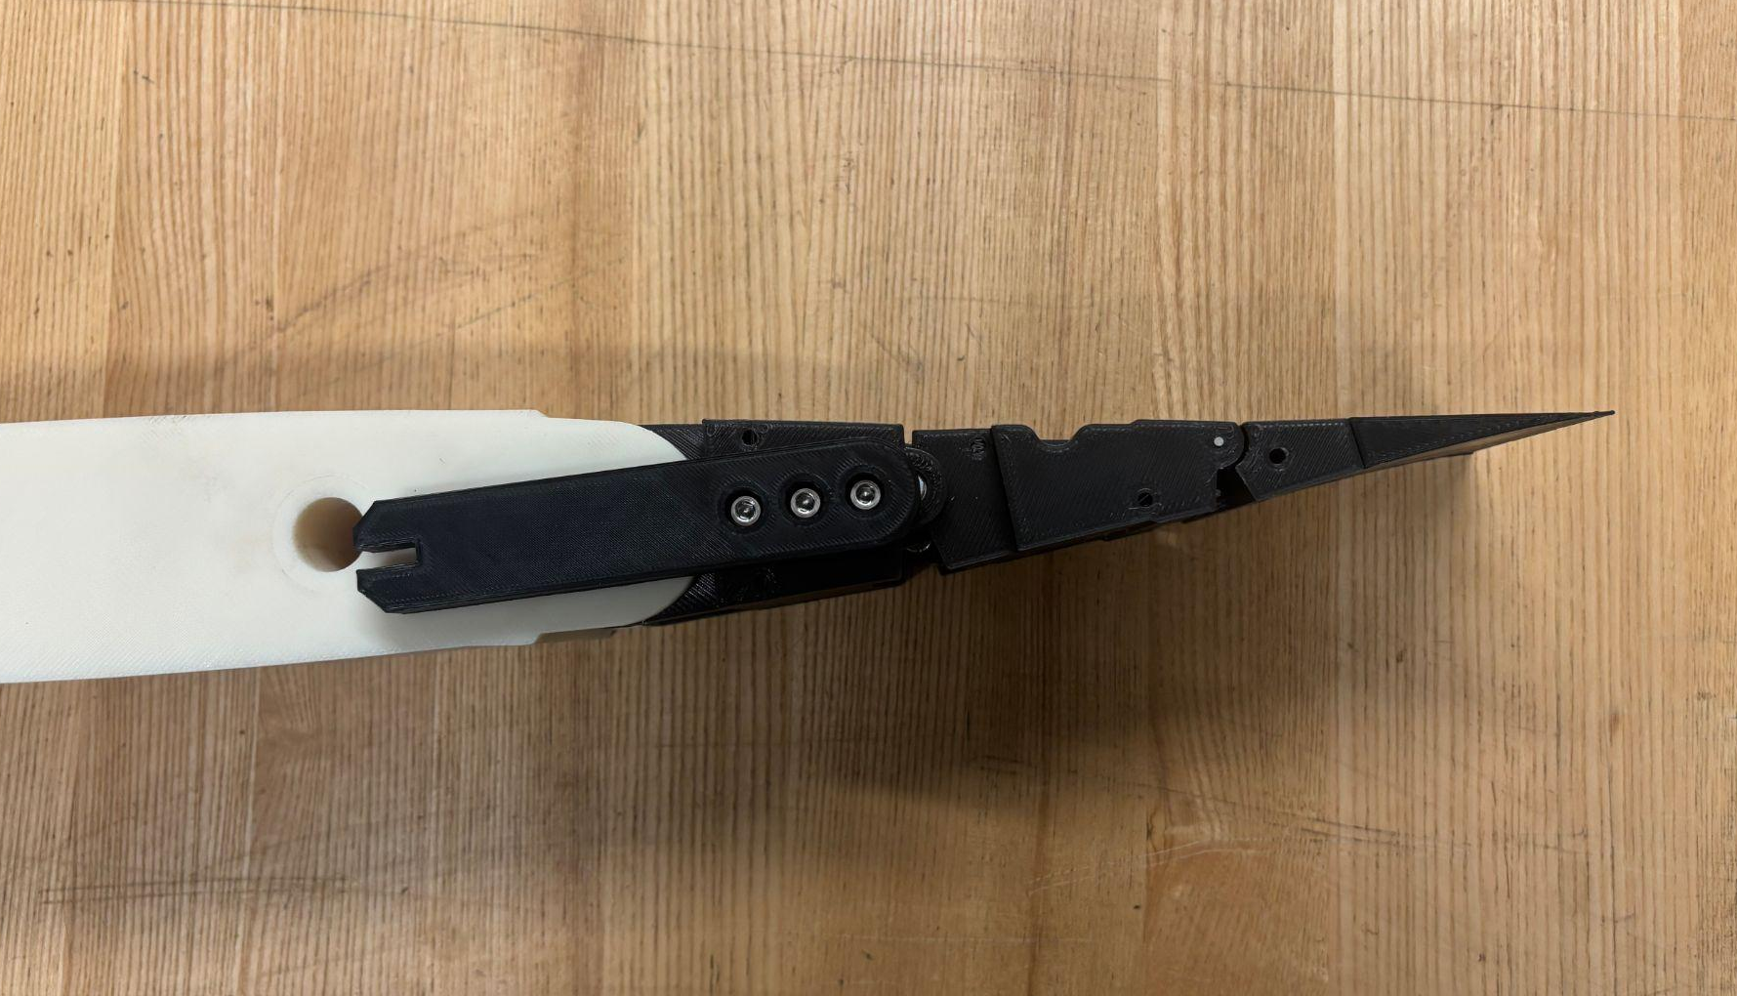
Figure 7: Second Generation Trailing Edge Prototype in 3 Actuation States
While the simplicity of these mechanisms limits how much the profile can change, having the ability to change the profile based on certain fluid conditions does improve the overall performance of the hydrofoil.

Silicone Composite Outer Skin
The silicone elastomer composite we constructed was tested both in tension and in out-of-plane deflection, and the results were compared to that of a plain silicone control sample with identical geometry. The tensile test produced an elastic modulus of 3.1639 kPa and 3.2035 kPa for the reinforced and control samples, respectively. This indicates that the addition of reinforcing materials does not compromise the “stretchiness” of the outer skin, allowing for expansion along the top or bottom surface of the trailing edge to accommodate camber adjustment. The out-of-plane test saw an 86.1% decrease in deflection for the reinforced sample versus the control under 10N of point load.
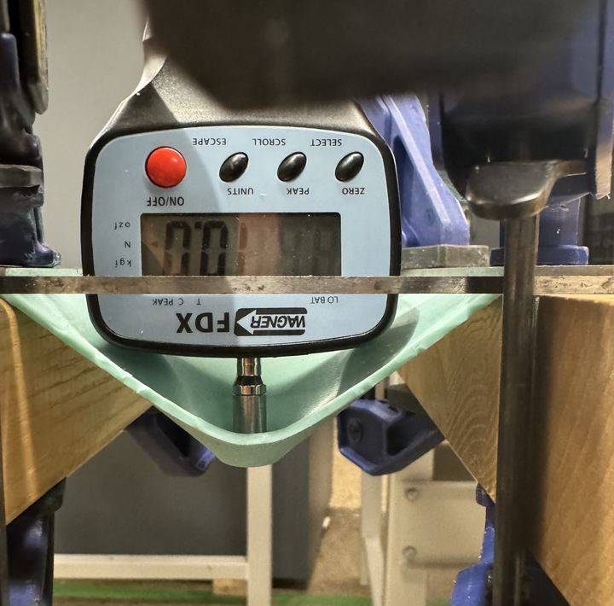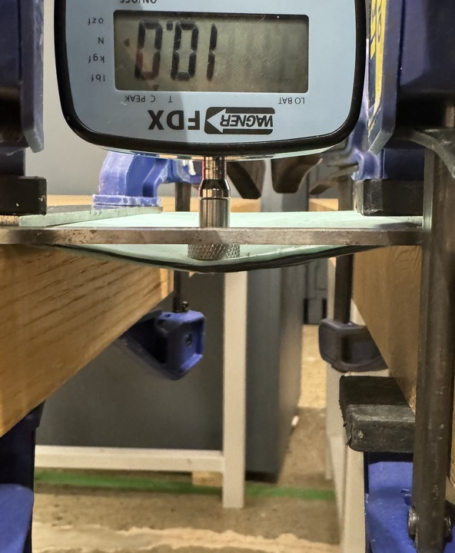
Figure 8: Plain (Left) and Reinforced (Right) Silicone Out-of-Plane Test
While the improved deformation value of 5mm is still too high for a real-life loading situation, it indicates a significant increase in out-of-plane rigidity. Further rigidity could be achieved through further materials research and experimentation.

Summary and Impact
While the specific application of this hydrofoil is for AC75 teams, the results of this project can be applied to hydrofoils in general. A hydrofoil that has morphing capabilities will see better performance than the current static foils that exist, whether or not it's for competitive purposes. In the world of competitive sailing, a morphing foil can bring new levels to the competition and allow teams to accomplish feats that have never been done before. For non-competitive applications, such as passenger ferries, a morphing foil can increase the efficiency of the vessel. Since the same fluid principles also apply to aircraft, these mechanisms can also be incorporated into plane wings for more efficient air travel. In general, the integration of morphing capabilities into a foil can lead to more efficient movement through fluids, whether it's a boat in the water or an aircraft in the sky.
The primary goal of this project was to develop a proof of concept to demonstrate the feasibility of creating a mechanism that can dynamically adjust the shape of a hydrofoil to maximize performance under various flow conditions. The next step in further demonstrating the benefits of a morphing mechanism would be to develop a full wing prototype that can be used in sea trials. This development and optimization can further be explored in 3 main areas: outer shell/skin material, internal morphing mechanisms, and further optimized 3D wing geometry.
The main focus of further materials development would be to create a fully continuous skin out of a reinforced elastomer. The features the skin would need to be viable for a real-world application are the ability to be watertight, a low risk of fatigue failure due to continuous morphing, and strong enough to resist deformation due to external fluid forces.
The internal morphing mechanisms for both thickness and camber adjustment can be further developed so that they are properly sized to withstand continuous hydrodynamic loads. These components will need to be manufactured with more advanced techniques & stronger materials, such as CNC machining and additive manufacturing with metals. Alternative ways of controlling these mechanisms can be explored, such as using hydraulics as a means of actuation. Further refining of the internal mechanisms would coincide with the optimization of the 3D wing profile. This means finding a balance between the external wing shape and the packaging of the internal mechanisms that results in the best overall performance.

References
[1] Sara La, “Morphing airfoil prototype.” Apr. 2018. Accessed: July 18, 2025. [Online]. Available: https://www.youtube.com/watch?v=9NnUbcTbWM4
[2] X. Shi, Y. Yang, Z. Wang, S. Zhang, X. Sun, and W. Feng, “Design and Shape Monitoring of a Morphing Wing Trailing Edge,” Aerospace, vol. 10, no. 2, Art. no. 2, Feb. 2023, doi: 10.3390/aerospace10020127.
[3] R. Vos and R. M. Barrett, “PRESSURE ADAPTIVE HONEYCOMB: A NOVEL CONCEPT FOR MORPHING AIRCRAFT STRUCTURES”.
[4] O. Schorsch, C. Nagel, and A. Lühring, “Chapter 7 - Morphing Skin: Foams,” in Morphing Wing Technologies, A. Concilio, I. Dimino, L. Lecce, and R. Pecora, Eds., Butterworth-Heinemann, 2018, pp. 207–230. doi: 10.1016/B978-0-08-100964-2.00007-1.
[5] D. Ahmad, D. Kumar, and R. M. Ajaj, “Multiaxial Deformations of Elastomeric Skins for Morphing Wing Applications: Theoretical Modeling and Experimental Investigations,” Polymers, vol. 14, no. 22, p. 4891, Nov. 2022, doi: 10.3390/polym14224891.
[6] A. Racing, “Carbon Fibre,” Athena Racing. Accessed: Aug. 14, 2025. [Online]. Available: http://www.athenaracing.com/en/articles/400_Carbon-Fibre.html
[7] M. Grabow et al., “Influence of the manufacturing process on the interlaminar tensile strength of thick unidirectional continuous epoxy/carbon fibre composites,” Compos. Part Appl. Sci. Manuf., vol. 154, p. 106754, Mar. 2022, doi: 10.1016/j.compositesa.2021.106754.
[8] “How Manufacturer Build Hydrofoils: 9 Steps & 37 Sub-processes.” Accessed: Aug. 14, 2025. [Online]. Available: https://www.unitysurf.com/how-manufacturer-build-hydrofoils/
[9] A. Crass, “Thermoplastics, Elastomers and Thermosets,” Performance Plastics. Accessed: Aug. 13, 2025. [Online]. Available: https://performanceplastics.com/blog/thermoplastics-elastomers-and-thermosets-what-material-is-best-for-my-project/
[10] C. Thill, J. Etches, I. Bond, K. Potter, and P. Weaver, “Morphing skins,” Aeronaut. J., vol. 112, pp. 117–139, Mar. 2008, doi: 10.1017/S0001924000002062.
[11] E. A. Bubert, B. K. S. Woods, K. Lee, C. S. Kothera, and N. M. Wereley, “Design and Fabrication of a Passive 1D Morphing Aircraft Skin,” J. Intell. Mater. Syst. Struct., vol. 21, no. 17, pp. 1699–1717, Nov. 2010, doi: 10.1177/1045389X10378777.
[12] A. G. Domel, M. Saadat, J. C. Weaver, H. Haj-Hariri, K. Bertoldi, and G. V. Lauder, “Shark skin-inspired designs that improve aerodynamic performance,” J. R. Soc. Interface, vol. 15, no. 139, p. 20170828, Feb. 2018, doi: 10.1098/rsif.2017.0828.
[13] M. A. Fatiha, B. Augier, F. Deniset, P. Casari, and J. A. Astolfi, “Morphing Hydrofoil Model Driven by Compliant Composite Structure and Internal Pressure,” J. Mar. Sci. Eng., vol. 7, no. 12, p. 423, Nov. 2019, doi: 10.3390/jmse7120423.
[14] G. W. Ng, A. Yildirim, H. Youngren, A. Lamkin, E. Jonsson, and J. R. R. A. Martins, “Design Optimization of America’s Cup AC75 Hydrofoil Sections with Flaps,” J. Sail. Technol., vol. 10, no. 01, pp. 50–73, May 2025, doi: 10.5957/jst/2025.10.1.50.

Appendix: Engineering Analysis

Introduction
The critical analysis for this project consists of identifying the target hydrofoil profiles that satisfy performance improvements as defined by the America’s Cup operating conditions. This condition was satisfied by identifying 7 target profiles that improve or, at worst, maintain the same existing performance. The setup and operating conditions for the 2D and 3D simulations are shown in XFoil and ANSYS Fluent. These design decisions were then used to inform the trailing-edge linkage design, a 6-bar linkage system with a range of motion prescribed from the CFD simulations. Finally, we conducted silicone tensile testing to derive an elastic modulus used to back-calculate the loads placed onto the driving shafts and motors.

CFD Analysis
To generate the foil profiles, a series of 2D flow simulations was conducted in XFoil, which uses the source panel method for rapid iteration of viscous and inviscid flow to predict lift, drag, pressure coefficients, and boundary-layer performance. While XFoil provides rapid analysis with high accuracy, it cannot model cavitation or large-scale separation. To verify the final geometry and calculate real-world load cases, 3D simulations in ANSYS Fluent were conducted.
Using XFoil and the target design points defined in Table 1, individual profiles were tested for each Reynolds number and lift coefficient under given design constraints. Reference performance for each condition, taken from Professor Martin’s research [10], includes the minimum pressure coefficient and the C_{p} vs. x plots for each design point. Since XFoil cannot predict cavitation, this was accounted for by reducing the local C_{p, Min} on the suction surface of the hydrofoil, satisfying Equations 2 and 3 below.
$σ=\frac{p_{∞}-p_{v}}{\frac{1}{2} {⍴V}_{∞}}$ (2)
$C_{p}=\frac{{p - p}_{∞}}{\frac{1}{2} ⍴V_{∞}}$ (3)
p = p_{v} (4)

where p∞ is the freestream pressure, V∞ is the velocity, 𝜌 is density, p is the local pressure, and p_{v} is the vapor pressure of water. Here, cavitation occurs at C_{p} = -𝜎.
The starting baseline profile obtained is shown below in Figure 9 alongside the hydrofoil paneling shown in Figure 10.
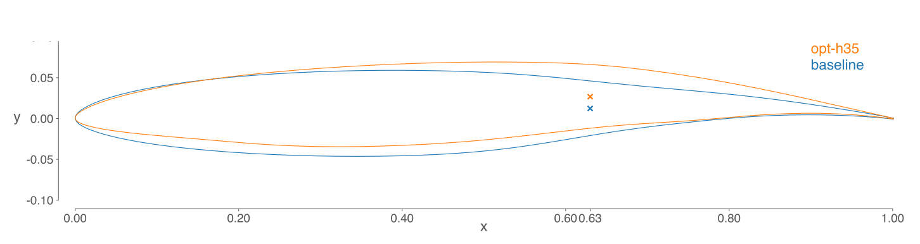
Figure 9: Optimized AC75 Foil Profile from Prof. Martins and The University of Michigan [10]

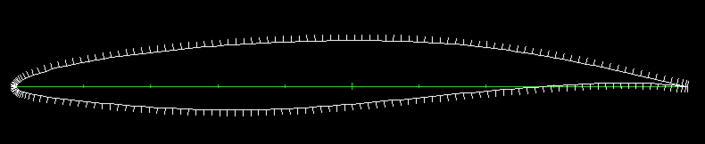
Figure 10: Panel Density From XFoil at a Chord of 1m
Each foil profile was generated using a parametrized sketch, with the linkage system hinged at 40% of the chord length from the trailing edge. The input geometry is uniform about a chord length of 1 and prescribed to the panel parameters shown in Table 3.
Table 3: XFoil Paneling Parameters
Panel Nodes Qty | Bunching Parameter | Trailing/Leading Edge Density | Panel Bunching Parameter | Leading Edge Panel Density | Max Panel Angle (degrees)
200 | 1 | 0.2 | 1.8 | 0.25 | 10.66
The flow around the hydrofoil is assumed to be turbulent due to the unpredictable and dynamic operating environment of sailing a boat in the ocean. As a result, a flow trip was prescribed in XFoil at 0.01% of the chord length to simulate turbulent flow conditions; it cannot be set to zero due to the stagnation point requiring a laminar assumption to develop. These settings are shown below in Table 4. At a higher angle of attack (⍺), the stagnation point shifts downwards, which is reflected by a shift in the x-trip location on the bottom surface to satisfy a convergence condition.
Table 4: XFoil Viscous Flow Parameters
⍺ | Ncrit | X-trip top %c | X-trip bottom %c | Iterations
<1.5º | 3 | 0.01 | 0.01 | 50
1.5-2º | 3 | 0.005 | 0.015 | -
The panel bunching parameter in XFoil controls how tightly panels are clustered toward the leading and trailing edges when generating the surface paneling for an airfoil. Two of the resulting simulations for the M1 condition are shown in Figures 6a and 6b alongside the data comparison in Table 2. The M1 condition is where morphing benefits are maximized, and the high Reynolds number conditions are set to minimize performance loss from drag or cavitation.
A continuation of this study was conducted using ANSYS Fluent to validate the performance improvement of our optimized theoretical profile in 3D flow simulations, in addition to generating worst-case scenario loading conditions on the internal linkage mechanism. The mesh for the simulation can be seen below in Figure 11.
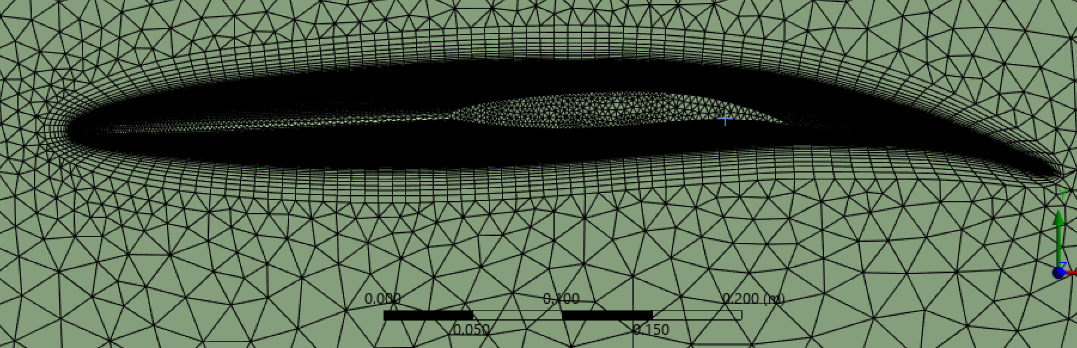
Figure 11: 3D Mesh & Inflation Layer of Optimized M1 Profile
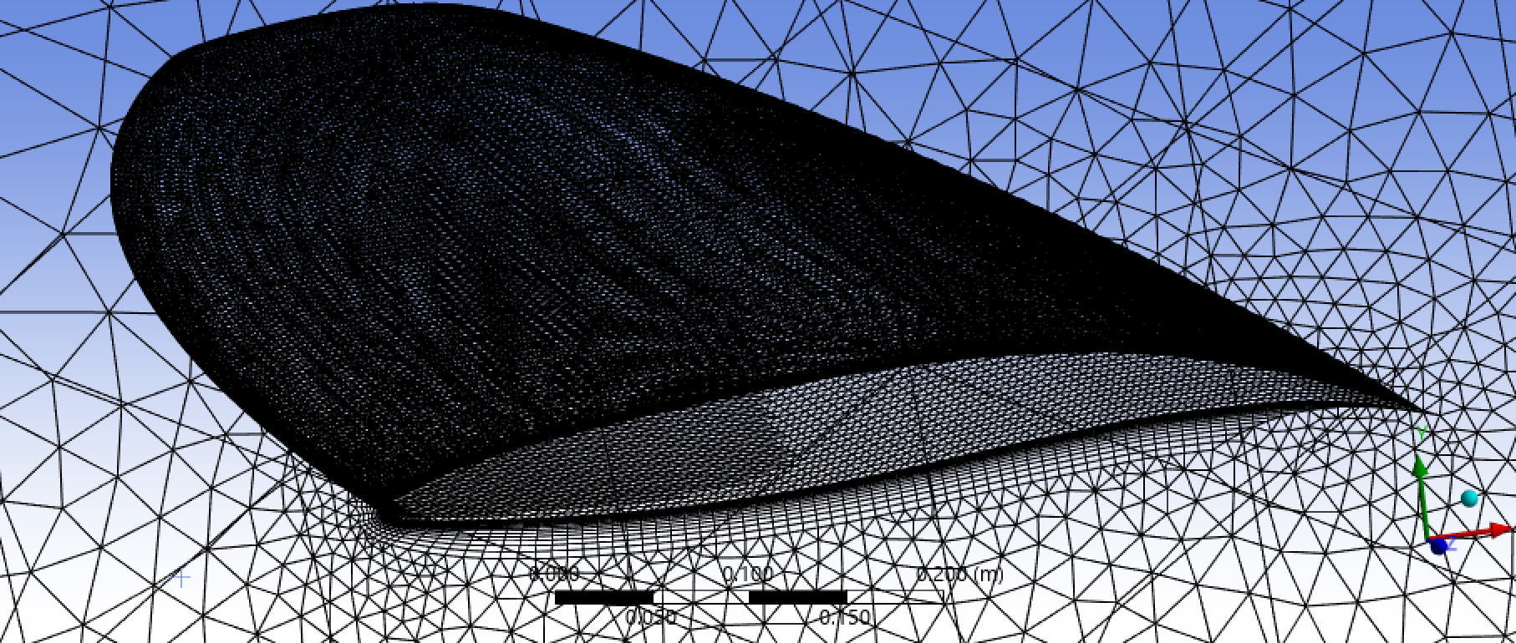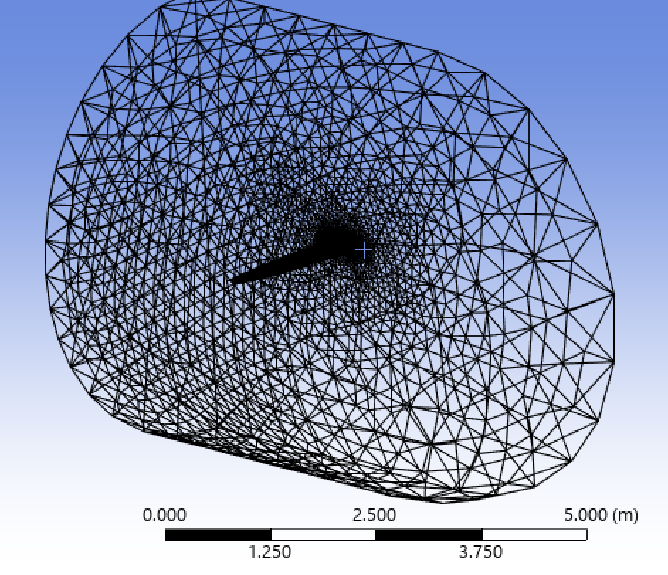
(a) (b)
Figure 12: The Local Mesh (a) and Total Domain Mesh (b) for the 3D profile at the M1 Condition
The operating conditions are shown in Table 5 for saltwater alongside the key profile dimensions. Due to the scaling limitations of the linkage mechanism, the profile ends at 50% of the root chord, reducing the wing span by 14%. While a fixed wing would continue, the solution omits this for comparison purposes.
Table 5: 3D Flow Operating Conditions
𝜌 (kg/m³) | Kinematic Viscosity(kg m /s) | V∞ (m/s) | Chord (m) | Wingspan (m)
1025 | 0.00122 | 6.68 | 0.414 | 1.657

The velocity vector profiles for the M1 condition can be seen in Figure 13a and 13b, illustrating the large flow separation on the baseline foil compared to the improved flow separation on the optimized profile. This significant improvement validates the effectiveness of the mechanisms in the morphing wing.

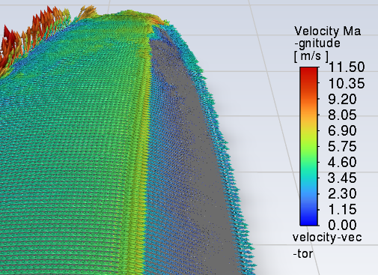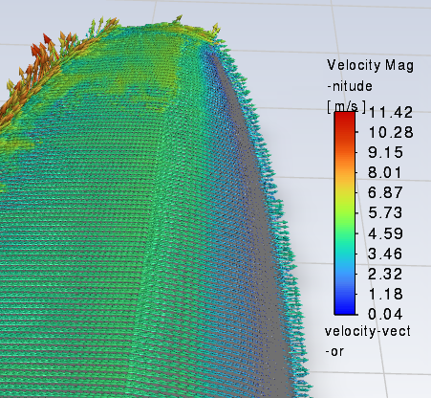
(a) (b)
Figure 13: Velocity Vector Plot for the Baseline (a) and Optimized Profile (b) at the M1 Condition

Silicone Composite Testing
Tensile and point load tests were used to evaluate how the unidirectional carbon fiber reinforcements affect the silicone outer skin. The tensile test followed ASTM D412, with samples cut into dogbone shapes featuring a 13 mm narrow section. Each sample was clamped in an Instron machine, pre-tensioned to about 0.1 kgf, then pulled at 500 mm per minute while force and displacement were recorded. The test concluded once the sample reached high strain levels, typically above 200 percent, and began to slip from the grips. The resulting stress-strain curves for the reinforced and plain samples can be seen in Figure 14 below.
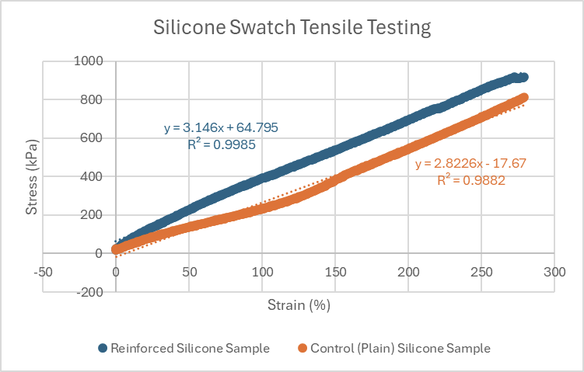
Figure 14: Stress vs strain for silicone swatch tensile testing
Analyzing the linear elastic regions of the stress-strain curves, Young’s modulus can be derived. The elastic modulus of the reinforced and plain samples was found to be 3.146 kPa and 2.823 kPa, respectively. As expected, the addition of carbon fiber produced only a marginal increase in stiffness relative to the baseline silicone mixture. The elastic modulus of the reinforced sample was then used to back-calculate the static loads exerted by the skin on the driving shafts, determining the minimum required input torque to size stepper motors.

Actuation Force Sizing
When the mechanisms in the trailing edge actuate, the elastomer skin is constantly pretensioned, applying a reaction force onto the internal structure and driving shafts. To prevent any failures, limit motor backdrive, and prevent excessive angular deflection, the driving motors needed to be sufficiently sized to overcome these internal reaction forces. To compensate for this, a series of static design calculations of the reaction forces and applied loads at the maximum actuations was compiled in MATLAB to identify the minimum required motor holding torque of 30 Nm. The key factors in specifying these motors were the elastic modulus and the effective stretching length of the composite silicone elastomer skin. This served as a critical system design to ensure the functionality of the overall morphing mechanism.

